**Marketing Email Generator – Usage Guide** *- v1.0*

1. *Installation*

Download the software package from <http://qa.travimp.com/sandbox/email_templating_v1.0.zip>

Make sure you have you have a local environment capable of running PHP 5.3+. If you are running in a Windows environment, this is taken care of for you if you install Wampserver (<http://www.wampserver.com/en/>), Xampp (<http://www.apachefriends.org/en/xampp.html>), or some other WAMP environment setup. The rest of this guide will assume that you are running WAMP with ‘http://localhost/’ being the root WAMP URL.

When your local environment has been set up, unzip the software files into a directory in your webroot that will be accessible via a browser.

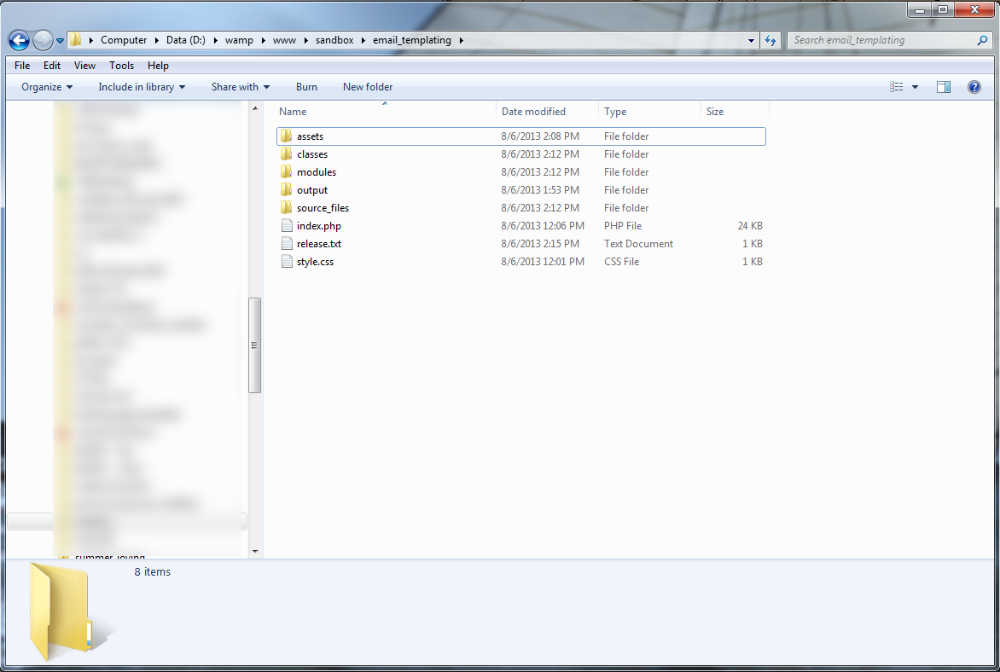

The following folders and file are include in the archive:

**‘assets’** – Image files that will be included in an email are put in this folder prior to running the program.

**‘classes’** – Software usage. Do not modify

**‘modules’** – Software usage. Do not modify

**‘output’** – output folder for finished email HTML

**‘source_files’** – Example Excel templates and corresponding assets files. Also contains ‘MasterEmailTemplate.xlsx’, which contains source template layouts for all modules.

**‘index.php’** – Main software file.

**‘release.txt’** – Release notes.

**‘styles.css’** – Styling markup.

1. *Running the software*

Open up a browser and go to [http://localhost/](http://localhost/email_templating/) to see your WAMP homepage. Then, click on the folder you installed the Marketing Email Generator to launch the program. You should get a screen that looks like the below:

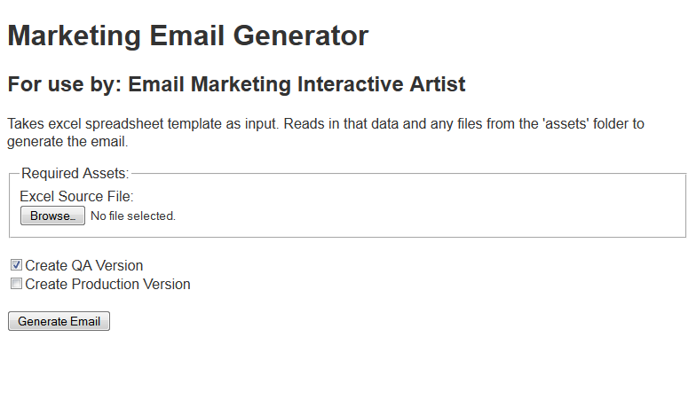

It ‘s a good idea to bookmark this page if you plan on using the software often. At this point, you are ready to start setting up your Excel source file and stage your assets.

1. *Excel Source Setup*

The program reads in an Excel source file that is formatting accordingly for whichever email and corresponding modules you desire. The only parts that are required for every email are the first 6 rows that provide meta data and the ‘HeaderModule’ section. The rest of the modules are optional and can be added, stacked, and duplicated as much as necessary. The ‘FooterModule’, ‘SocialModule’, ‘LinkFarmModule’, and ‘FooterTermsModule’ should almost always be the last modules in the stack.

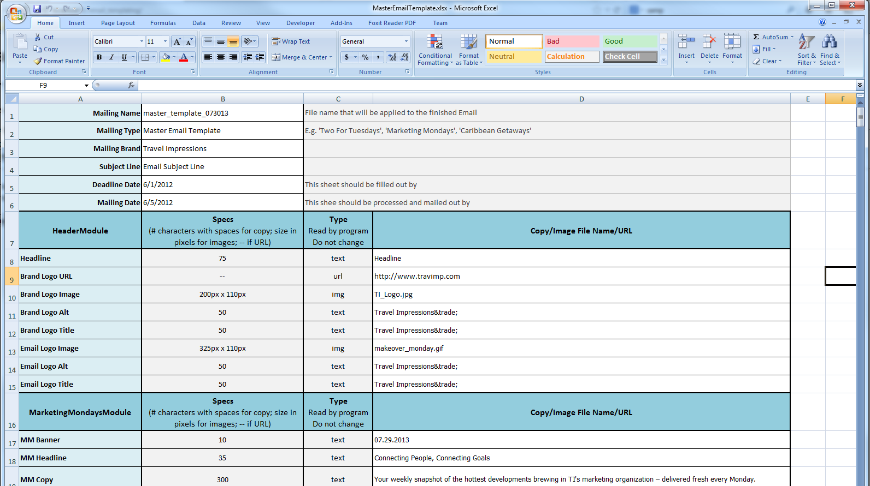

**‘Mailing Name’** – The name of the finished HTML file for your email.

**‘Mailing Type’** – The name of the email type. Eg. 'Two For Tuesdays', 'Marketing Mondays', 'Caribbean Getaways'

**‘Mailing Brand’** - 'Travel Impressions' or 'American Express'. This will delegate where the email HTML and assets will be uploaded and the branding on the email HTML

‘Subject Line’ – Email Subject Line

**‘Deadline Date’** – Deadline for the email content and assets to be provided.

**‘Mailing Date’** – The date the email should be sent out.

Under each module, all the individual component types should be filled in to complete the module. The right information should be provided for each tag type. Tag types are described below:

**‘text’** – Normal text.

**‘url’** – A complete URL to a web address. E.g. – <http://www.travimp.com>

**‘img’** – file name of an image asset. There must be a corresponding image in the ‘assets’ folder with this exact name for the image to show up in the email correctly.

**‘html’** – Normal text with HTML markup. Only markup that is valid for email is should be entered.

1. *Email Creation*

Once you have a completed Excel source file and corresponding assets in the ‘assets’ folder, you’re ready to run the software and produce your email. Browse for your Excel source file and make sure you have the versions of the email you want to create selected. ‘Create QA Version’ will run the process for creating and uploading a QA version and ‘Create Production Version’ will do the same for a Production version. By default, ‘QA’ is selected. When you are finished with setup, hit ‘Generate Email’ to run the process.

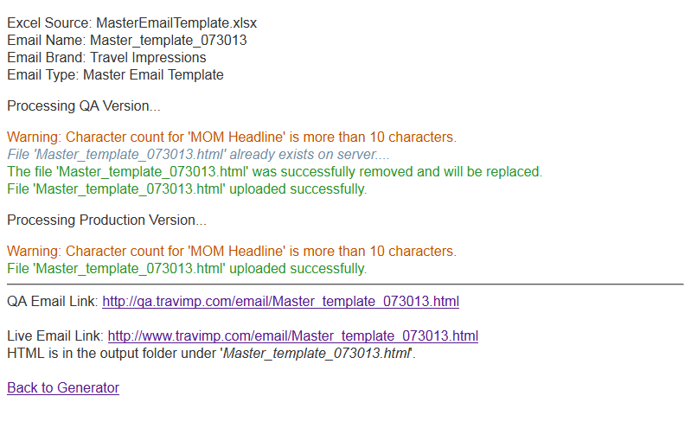

The Generator will read through your Excel source file and output the results. Depending on which versions were selected at run, you will get ‘Processing QA Version…’, ‘Processing Production Version…’, or both. You will also be provided with links to the finished QA and/or Production email on the server. You will always be provided with a reference to the HTML output of the email which goes to the ‘output’ folder.

Once the process is done, you or whoever will be editing/finishing the email can edit the finished the HTML using Dreamweaver or any other editor of their choice. Alternatively, the Excel source file and assets can be edited and then the program rerun against them. All the previously uploaded files will be updated. **If you make edits to HTML or image assets that were generated/updated by this program and then run the program again, they will be overwritten.** It is best start editing an email’s HTML outside of the Generator when you are confident you will not need to run the Generator again.

1. *Troubleshooting*

If you are having issues with the programs functionality, the entire program can be reinstalled simply by deleting all the install files from your chosen install directory and unzipping all program files back into the directory again. If you’re still having difficulty, email the developer: [Stavros.louris@travimp.com](mailto:Stavros.louris@travimp.com)